Session 15: Using Database Query Agent in a Java Web Application

What is a Database Query Agent?
A Database Query Agent is a specialized Java class (often part of the DAO – Data Access Object pattern) that acts as a middle layer between your web application and the database. Its job is to:
- Send SQL queries to the database
- Receive and process results
- Return the data to Servlets, Controllers, or JSPs

Why use a Database Query Agent?
Using a query agent brings structure, security, and scalability to your web app:
Benefit | Description
Separation of concerns | Keeps SQL logic away from UI/Servlet code
Reusability | Same query agent can be reused in multiple pages or features
Maintainability | Easier to debug and extend database logic
Security | Encourages safe query handling (e.g., PreparedStatements to avoid SQL Injection)

Libraries use a Database Query Agent in Java Web Applications
okio-1.17.5.jar
- What it is: A library developed by Square, used for fast and efficient I/O operations.
- Why it’s used: Handles data streaming (like file reading/writing or network streaming) efficiently with buffers.
- Use case: Usually used under the hood by libraries like OkHttp for HTTP connections.
kotlin-stdlib-jdk7-1.4.0.jar
- What it is: Kotlin Standard Library (for JDK 7) — contains core Kotlin features like collections, IO utilities, etc.
- Why it’s used: Enables Kotlin code to run in Java applications.
- Use case: Required if your project (or one of the libraries like OkHttp) includes Kotlin code.
okhttp-3.14.9.jar
- What it is: An HTTP client library for making REST API calls, developed by Square.
- Why it is used: Simple and powerful way to make HTTP(S) requests (GET, POST, etc.) from Java.
- Use case: You use this if your web app communicates with APIs (e.g., for AI agents, REST services).
json-20210307.jar
- What it is: A popular Java library (by org.json) to parse and generate JSON.
- Why it’s used: Helps in converting Java objects and JSON strings (serialization/deserialization).
- Use case: Needed if you're working with AJAX, REST APIs, or sending/receiving JSON data.

Example: Implementing Java Web Application
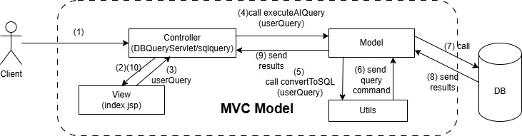
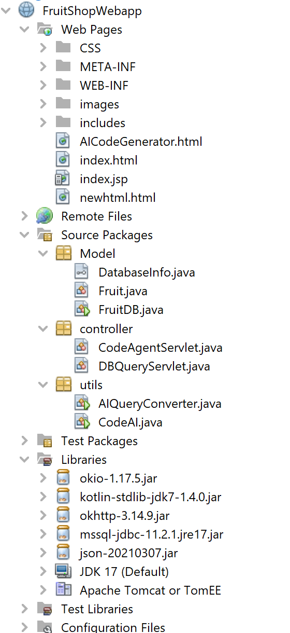
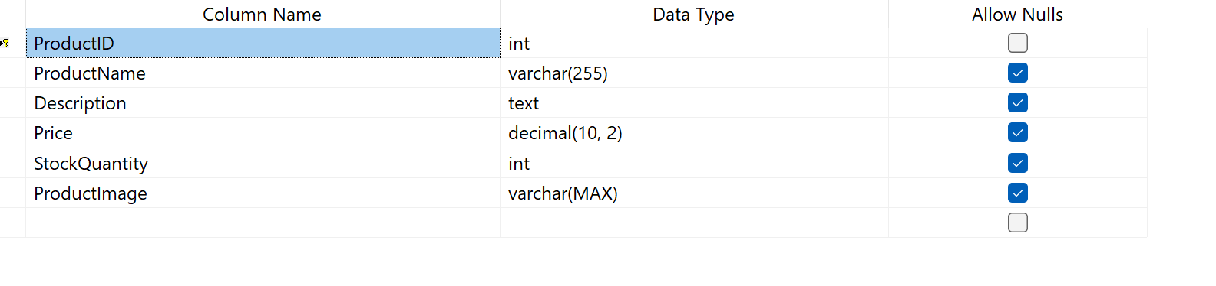
-- Products table
CREATE TABLE Products (
ProductID INT PRIMARY KEY,
ProductName VARCHAR(255),
Description TEXT ,
Price DECIMAL(10, 2) CONSTRAINT CHK_Price_Positive CHECK (Price >= 0),
StockQuantity INT CONSTRAINT CHK_StockQuantity_NonNegative CHECK (StockQuantity >= 0),
ProductImage VARCHAR(MAX),
);
-- Insert fruit products for a fruit shop
INSERT INTO Products (ProductID, ProductName, Description, Price, StockQuantity, ProductImage)
VALUES
(1, 'Red Delicious Apples', 'Sweet and crispy apples',50 ,20,'/images/RedDeliciousApples.jpg'),
(2, 'Cavendish Bananas', 'Fresh and ripe bananas',30 ,25,'/images/CavendishBananas.jpg'),
(3, 'Navel Oranges', 'Juicy and seedless oranges',35 ,30,'/images/NavelOranges.jpg'),
(4, 'Strawberries', 'Sweet and succulent strawberries',45,30, '/images/Strawberries.jpg'),
(5, 'Lemons', 'Tangy and aromatic citrus fruits', 32 ,35,'/images/Lemons.jpg'),
(6, 'Pineapples', 'Exotic and tropical pineapples', 42,20,'/images/Pineapples.jpg');
Code
package Model;
public interface DatabaseInfo {
public static String DRIVERNAME="com.microsoft.sqlserver.jdbc.SQLServerDriver";
public static String DBURL="jdbc:sqlserver://DESKTOP-09JBLVE;databaseName=FruitShop_AI;encrypt=false;trustServerCertificate=false;loginTimeout=30;";
public static String USERDB="sa";
public static String PASSDB="123";
}
package Model;
import java.io.Serializable;
public class Fruit implements Serializable {
private int productId;
private String productName;
private String description;
private double price;
private String image;
public Fruit () {}
public Fruit(int productId, String productName, String description, double price, String image) {
this.productId = productId;
this.productName = productName;
this.description = description;
this.price = price;
this.image = image;
}

public Fruit(int productId, String productName, String description, double price) {
this.productId = productId;
this.productName = productName;
this.description = description;
this.price = price;
}
public String getImage() {
return image;
}
public void setImage(String image) {
this.image = image;
}
// Getter methods for product properties
public int getProductId() {
return productId;
}
public String getProductName() {
return productName;
}
public String getDescription() {
return description;
}
public double getPrice() {
return price;
}

public Fruit(Fruit s){
this(s.productId,s.productName,s.description,s.price);
}
public Fruit(int id){
this(FruitDB.getFruit(id));
}
public int addNew(){
return FruitDB.newFruit(this);
}
public Fruit update(){
return FruitDB.update(this);
}
public int delete(){
return FruitDB.delete(this.productId);
}
@Override
public String toString() {
return "Fruit{" + "productId=" + productId + ", productName=" + productName + ", description=" + description + ", price=" + price + ", image=" + image + '}';
}
}

package Model;
import java.sql.*;
import java.util.ArrayList;
import java.util.function.Predicate;
import java.util.logging.Level;
import java.util.logging.Logger;
import utils.AIQueryConverter;

public class FruitDB implements DatabaseInfo{
public static Connection getConnect(){
try{
Class.forName(DRIVERNAME);
} catch(ClassNotFoundException e) {
System.out.println("Error loading driver" + e);
}
try{
Connection con = DriverManager.getConnection(DBURL,USERDB,PASSDB);
return con;
}
catch(SQLException e) {
System.out.println("Error: " + e);
}
return null;
}
/*public static Connection getConnect(){
try{
Context initContext = new InitialContext();
Context envContext = (Context) initContext.lookup("java:/comp/env");
DataSource ds = (DataSource) envContext.lookup("jdbc/mydb");
return ds.getConnection();
} catch (SQLException | NamingException ex){
System.out.println("Error: " + ex);
}
return null;
}*/
// New Method: Execute AI-Generated SQL Query
public static ArrayList<Fruit> executeAIQuery(String userQuery) {
ArrayList<Fruit> list = new ArrayList<>();
try (Connection con = getConnect()) {
// Convert user query to SQL using AI
String sqlQuery = AIQueryConverter.convertToSQL(userQuery);
//System.out.println("sqlQuery" + sqlQuery);
//System.out.println("sqlQuery:" + sqlQuery);
PreparedStatement stmt = con.prepareStatement(sqlQuery);
ResultSet rs = stmt.executeQuery();
while (rs.next()) {
list.add(new Fruit(rs.getInt(1), rs.getString(2), rs.getString(3), rs.getDouble(4), rs.getString(6)));
}
con.close();
} catch (Exception ex) {
Logger.getLogger(FruitDB.class.getName()).log(Level.SEVERE, null, ex);
}
return list;
}
}

package utils;
import Model.Fruit;
import Model.FruitDB;
import java.util.ArrayList;
import java.util.concurrent.TimeUnit;
import okhttp3.*;
import org.json.JSONObject;
public class AIQueryConverter {
private static final String API_URL = "https://api.cohere.ai/v1/generate";
private static final String API_KEY = "Bearer kp2OQr0DYK9FTuCtgM7d3lJd0JaL9mZssBAVKL9g"; // Free
public static String convertToSQL(String userQuery) throws Exception {
OkHttpClient client = new OkHttpClient.Builder()
.connectTimeout(30, TimeUnit.SECONDS) // Increased connection timeout
.readTimeout(30, TimeUnit.SECONDS) // Increased read timeout
.writeTimeout(30, TimeUnit.SECONDS) // Increased write timeout
.build();
// Improved prompt to prevent AI from adding unwanted conditions
String formattedPrompt = "Convert this natural language query into an accurate SQL query using the correct schema:\n"
+ "Table: Products (Columns: ProductID, ProductName, Description, Category, Price, StockQuantity, "
+ "ProductImage, UnitOfMeasurement)\n"
+ "Query: " + userQuery + "\n"
+ "Rules:\n"
+ "- Only apply the filters explicitly requested in the user query.\n"
+ "- Return ONLY the SQL query, nothing else.";
JSONObject json = new JSONObject();
json.put("model", "command");
json.put("prompt", formattedPrompt);
RequestBody body = RequestBody.create(MediaType.parse("application/json"), json.toString());
Request request = new Request.Builder()
.url(API_URL)
.addHeader("Authorization", API_KEY)
.addHeader("Content-Type", "application/json")
.post(body)
.build();
Response response = client.newCall(request).execute();
String jsonResponse = response.body().string();
// Extract SQL query from the response
JSONObject responseObject = new JSONObject(jsonResponse);
return responseObject.getJSONArray("generations").getJSONObject(0).getString("text").trim();
}

import Model.Fruit;
import static Model.FruitDB.executeAIQuery;
import jakarta.servlet.ServletException;
import jakarta.servlet.annotation.WebServlet;
import jakarta.servlet.http.HttpServlet;
import jakarta.servlet.http.HttpServletRequest;
import jakarta.servlet.http.HttpServletResponse;
import java.io.IOException;
import java.io.PrintWriter;
import java.util.ArrayList;
@WebServlet(name = "DBQueryServlet", urlPatterns = {"/sqlquery"})
public class DBQueryServlet extends HttpServlet {
@Override
protected void doGet(HttpServletRequest request, HttpServletResponse response)
throws ServletException, IOException {
//processRequest(request, response);
request.getRequestDispatcher("index.jsp").include(request, response);
}
@Override
protected void doPost(HttpServletRequest request, HttpServletResponse response)
throws ServletException, IOException {
String userQuery = request.getParameter("userQuery");
response.setContentType("text/html");
PrintWriter out = response.getWriter();
ArrayList<Fruit> results = null;
try {
// Connect to database and execute query
results = executeAIQuery(userQuery);
} catch (Exception e) {
out.println("<p>Error: " + e.getMessage() + "</p>");
}
request.setAttribute("fruitList", results);
request.getRequestDispatcher("index.jsp").include(request, response);
}
}

Result
